**Business Problem**

In recent years, City hotel & Resort Hotel have seen high cancellation rates. Each hotel is now dealing with number of issues as a result, including fever revenues and less than ideal room use. consequently, lowering cancellation rates is both hotels primary goal to increase their efficiency in generating revenue, and for us to offer through business advise to address this problem.

The analysis of hotel booking cancellations as well as other factors that have no bearing on their business and yearly revenue generations are the main topics of this report.



**Assumptions**

1. No usual occurrence between 2015 and 2017 will have the substantial impact on the data used.

2. The information is still current and can be used to analyze a hotel's possible plans in an efficient manner.

3. There are no unanticipated negative to hotel employing any advised technique.

4. The hotels are not currently using any of the suggested solution.

5. The biggest factor affecting the effectiveness of earning income is booking cancellations.

6. Cancellations result in vacant rooms for the booked length of time.

7. Clients made hotel reservation for the same year they make cancellations.

**Research question**

1. What are the variables that affect hotel reservation cancellations?

2. How can we make hotel reservations cancellations better

3. How will hotels be assisted in making pricing & promotional decisions?

**Hypothesis**

1. More cancellations occur when prices are higher.

2. When there is longer waiting list, customer tend to cancel more frequently.

3. Many of the clients are coming from offline travel agents to make their reservations.

**Analysis and findings**

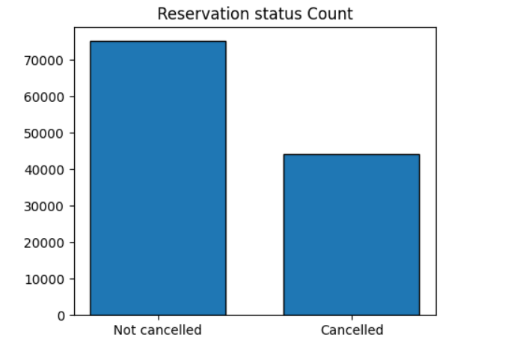

The accompanying bar graph shows the percentage of reservations that are cancelled and those that are not. It is obvious that there are still a significant number of reservations that have not been cancelled. There are still 37 % of the clients who cancelled their reservation. Which has significant impact on the hotel’s earnings.

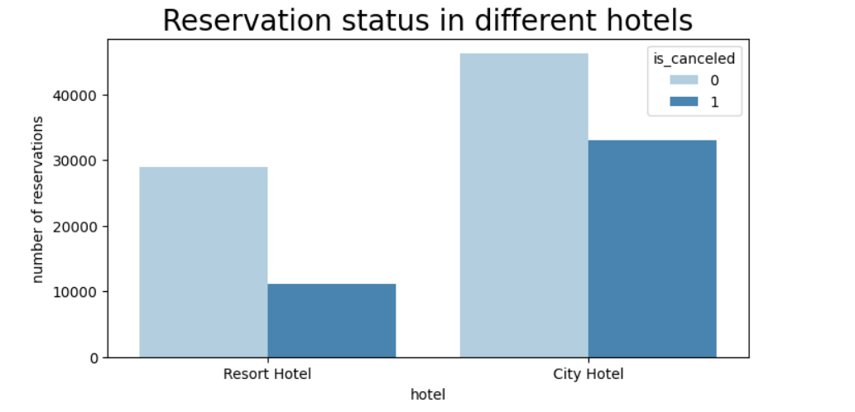

In comparison to resort hotels, city hotels have more bookings, it is possible that resort hotels are more expensive than those in cities.

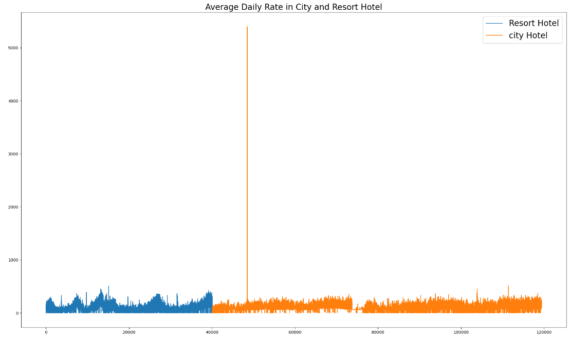

The above line graph shows that, on certain days the average daily rate for a city hotel is less than that of resort hotel, and on other days, it is even less. It goes without saying that weekend and holidays may have see a rise in resort hotel rates.

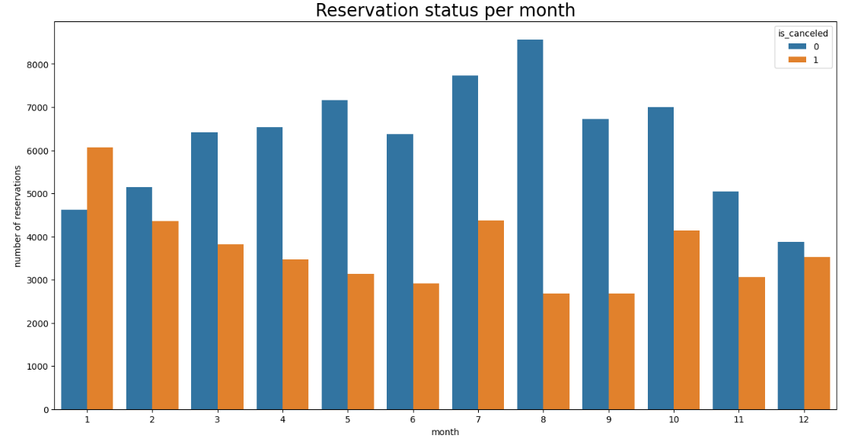

We have developed the grouped bar graph to analyze the months with the highest and lowest reservation status. As can be seen both the number of confirmed reservations and the number of cancelled reservations are largest in the month of August. whereas January is the month with the most cancelled reservations.

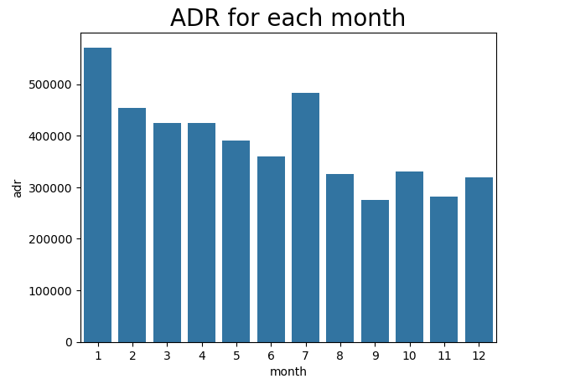

This bar graph demonstrates that cancellations are most common when prices are higher and are least common when they are lowest therefore, the cost of the accommodation is solely responsible to the cancellation.

Now, let us see which country has the highest reservation cancelled. The top country is Portugal with the highest number of cancellations.

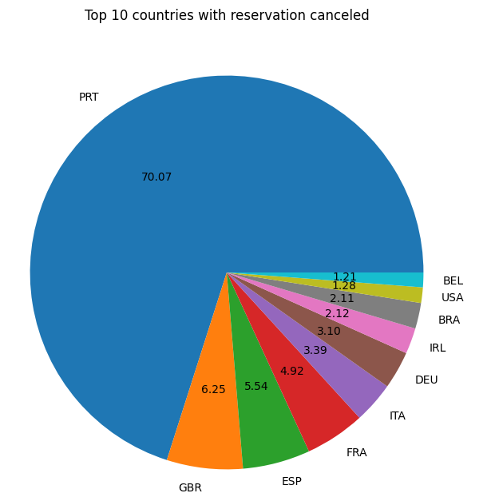

Let's check the area from where guests are visiting the hotels and making the reservations. Is it coming from Direct or Group. Online or office travel agents? Around 46 % of the clients come from the online travel agencies. whereas 27% come from groups. Only 4% of the clients book hotels directly by visiting them and making reservations.

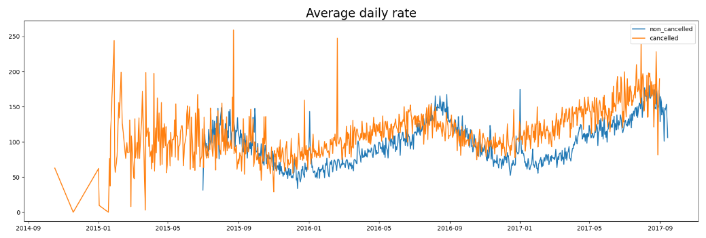

As seen in the graph, reservations are cancelled when the average daily rate is higher than when it is not cancelled. It clearly proves all the above analysis, that higher price leads to higher cancellation.

**Suggestions**

1. Cancellation rates rise as the price does, to prevent cancellations of reservations. Hotels could work on their pricing strategies and try to lower the rates for specific hotels based on locations they can also provide some discount to consumers.

2. As the ratio of cancellations and non-cancellation for resort hotel is higher than that of city hotels. So, the hotels should provide a reasonable discount on the room prices over weekends or on holidays.

3. In the month of January hotels can start campaign or marketing with a reasonable amount to increase their revenue as the cancellation is highest in this month.

4. They can also increase the quality of their hotels and their services mainly in Portugal to reduce the cancellation rate.